Net631 Week One practical (6-12)
Sbongakonke Mfeya

Introduction
CTU Training Solutions has tasked me with creating an online learning service for students. This document outlines the planning and cloud setup for providing students with online learning services. I’m going to use Microsoft Azure to support it. This system will store training materials, allow secure access, and ensure reliable availability of learning resources.

  - Business Requirements
- Provide secure storage for training materials
- Allow students to access learning resources remotely
- Ensure high availability of services
- Implement secure user authentication
- Support scalability for future growth
- Maintain data protection and backup capabilities
These requirements will ensure that students can access the training material remotely from anywhere.
  - Azure services required
- Azure Resource Group
- Azure Storage Account
- Azure Virtual Machine
- Azure Microsoft Entra ID
- Azure Monitor

  - Resource Group Creation
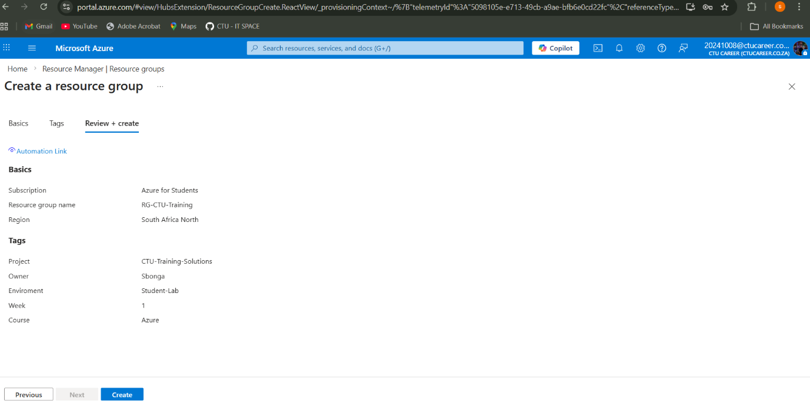

  - Azure Tags Configuration
  - 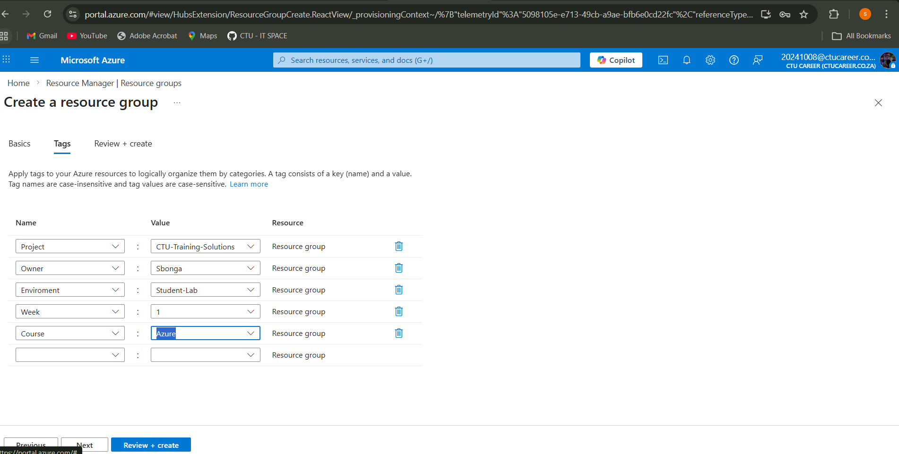
  - Resource Group Overview
  - 